**SYSTEM REQUIREMENTS**

**CSE 305 – SOFTWARE ENGİNEERİNG**

Ümit Zafer Karakuş(zaferkrkss), Mevlüt Batuhan Saar(m-batuhans), Baran Yıldız(brnnyildiz)

**Functional Requirements:**

* **Security**: Users must enter a personal user name and password in order to log into the system. No action can be made without entering the username and password. In this way, all information is protected.
* **Accuracy:** The system records every transaction made by the user in days, hours and minutes. Each recording can then be checked optionally. In this way, it is easy to find out who made mistakes, how and when.
* **Interoperability:** The system carries out sales and storage operations at the same time. In this way, the stocks are updated after each sale and the user can instantly observe the number of products.

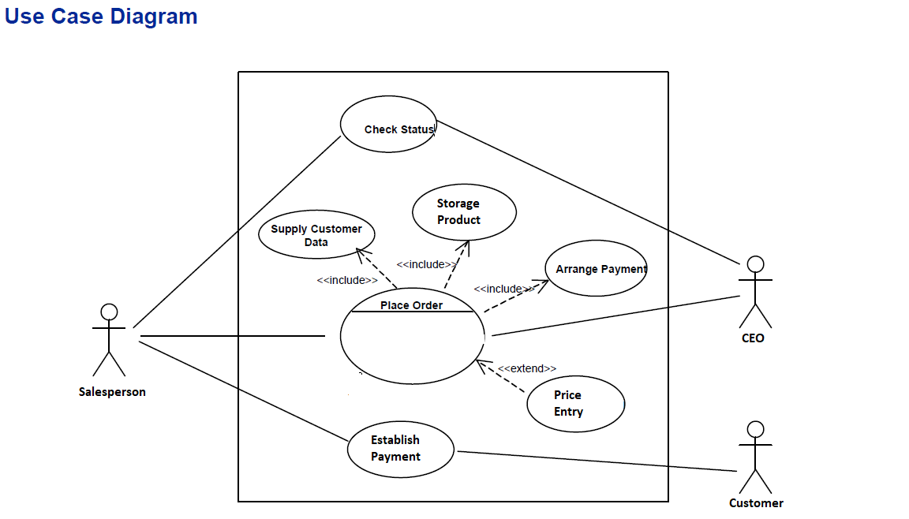

**Story**:

1. Storage Product: The products in the storage are monitored and what product is needed is determined, then the missing products are supplied and added to the storage.
2. Price Entry: Supplied products are controlled and price entry is provided to the system. If needed, the price list can be updated.
3. Place Order: A customer arrives at the checkout with items to be purchased. The cashier uses the system software to record every item purchased.
4. Supply Customer Data: The system presents a running total and line-item details.
5. Arrange Payment: The customer chooses cash or credit card methods as the payment method. Different rates of discount are applied according to the payment method chosen.
6. Establish Payment: Customers pay with the method they choose, and finally, a receipt is printed.
7. Check Status: The CEO or salesperson can check or correct past transactions at any time.

**Pre- And Post- Conditions:**

1. Pre: New products should be needed in the storage.

Post: The needed products should be taken and placed in the storage.

1. Pre: Supplied products must be checked.

Post: Price entry must be provided.

1. Pre: Customer must determine the products they want to buy.

Post: The cashier must enter the customer's products into the system.

1. Pre: The system checks the products.

Post: The system lists the products.

1. Pre: The customer chooses the payment method.

Post: The system calculates the discount.

1. Pre: The customer makes the payment.

Post: The system issues chips.

1. Pre: System status needs control.

Post: Checking the system.

**Decompose:**

While creating user stories, we have created them as short and clear as possible, for this reason there are no very large and complex user stories, which prevents the story from breaking into smaller parts.

**Non-Functional Requirements:**

* **Performance**: The system is capable of providing access to many users at the same time. Thus, even if many users enter the system at the same time, the system will not crash or give an error. The system can respond quickly to the action of a particular user under a given workload.
* **Usability:** The website’s interface is user-friendly and easy to use.
* **Availability: Customers can buy the products throughout week at any time during the day.** In the case of unplanned system downtime, all features will be available again after one working day.

**Glossary:**

* **Account book:** Account bookis the recording of financial transactions, and is part of the process of accounting in business**.**
* **Cashier:**  Cashier is a person who handles the [cash register](https://en.wikipedia.org/wiki/Cash_register) at various locations such as the [point of sale](https://en.wikipedia.org/wiki/Point_of_sale) in a [retail store](https://en.wikipedia.org/wiki/Retail_store).
* **Cash Payment**: Cash payment is bills or coins paid by the recipient of goods or services to the provider.
* **Catalog:** Catalog is a complete enumeration of items arranged systematically with descriptive details.
* **Credit Card Payment:** Credit card payment is paid with credit card by the recipient of goods or services to the provider.
* **Customer:** Customer is an individual or business that purchases another company's goods or services.
* **Payment:** Payment is the transfer of money, goods, or services in exchange for goods and services in acceptable proportions that have been previously agreed upon by all parties involved. A payment can be made in the form of services exchanged, cash, check, wire transfer, credit card, or debit card.
* **Product**: Product is an object or system made available for consumer use; it is anything that can be offered to a market to satisfy the desire or need of a customer.
* **Sale**: A sale is a transaction between two or more parties in which the buyer receives tangible or intangible goods, services, or assets in exchange for money.
* **Store**: Store is a place where goods are [sold](https://www.ldoceonline.com/dictionary/sell) to the public.